**Identification of Network Components**

**By Group no. 7 – AIML (C)**

|  |  |
| --- | --- |
| 16. Pawan Shetty | 18. Aryan Shinde |
| 17. Rishith Shetty | 19. Rohit Shinde |

**An Innovative Examination (IE) Report**

**Submitted for the**

**Subject of**

**P.C. Assembly Workshop**

**A.Y. 2024-25**

**Theoretical Background:**

**Networking is the backbone of modern communication systems, connecting devices, users, and systems to share resources and information. The primary components of a network include:**

* 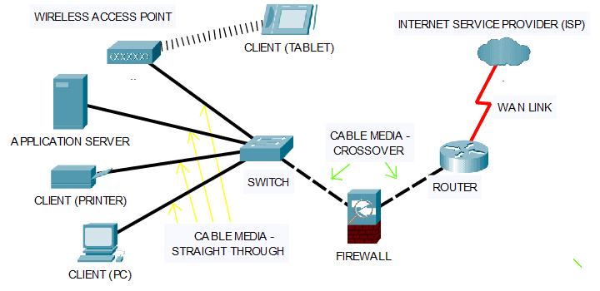**Hardware Components: Routers, switches, hubs, NICs (Network Interface Cards), cables, and modems.**
* **Software Components: Network operating systems, protocols like TCP/IP, and network management software.**
* **Transmission Media: Wired (Ethernet cables, fibre optics) and wireless (Wi-Fi, Bluetooth) channels.**

**The seamless operation of networks depends on the integration of these components, ensuring reliable data transmission and resource sharing.**

**Introduction:**

**With the growing dependence on networks in daily life, understanding the core components is critical. Networks, whether local (LAN) or wide area (WAN), consist of essential building blocks that enable connectivity, scalability, and security. This report aims to explore these components, their identification, and their roles in modern networking.**

**Methodology Used / Current Trends:**

**Methodology Used:**  
The identification of network components typically involves:

* **Visual Inspection**: Checking physical devices like routers and cables.
* **Network Analysis Tools**: Using software like Wireshark to inspect and diagnose network issues.
* **Configuration Interfaces**: Accessing device settings via web interfaces or command-line tools.

**Current Trends**:

* **Software-Defined Networking (SDN)**: Decouples control from hardware, making network management more flexible.
* **Cloud Networking**: Centralized network resources hosted in the cloud.
* **IoT Integration**: Devices with embedded networking capabilities for real-time monitoring and control.
* **5G Networks**: Enhanced speed and reduced latency for wireless communication.

**Applications and Implications:**

* **Applications**:
  + **Corporate Networks**: Facilitate communication and resource sharing within organizations.
  + **IoT Systems**: Enable interconnected smart devices for automation.
  + **Cloud Computing**: Supports scalable resource allocation for enterprises.
  + **Telecommunications**: Backbone of mobile and internet services.
* **Implications**:
  + Enhanced productivity and collaboration.
  + Greater vulnerability to cyberattacks due to increased connectivity.
  + The need for skilled professionals to manage complex networks.

**Future Scope:**

The identification and optimization of network components will become increasingly vital as:

* Networks evolve towards **quantum computing** for ultra-secure communication.
* **AI and machine learning** are integrated into network management for predictive analytics.
* **6G networks** emerge, offering unparalleled speed and connectivity.
* The demand for **greener, energy-efficient networks** grows.
* Nanomaterial Engineering: Understanding nanoscale vibrations in materials like graphene may lead to innovations in energy harvesting and sensor technology, impacting fields from telecommunications to aerospace.

**Conclusion:**

**Identifying and understanding network components is crucial for ensuring robust, secure, and efficient communication systems. The ongoing advancements in networking technologies highlight the importance of staying updated on hardware and software trends to meet the demands of a connected world.**

References:

1. Tanenbaum, A., & Wetherall, D. (2010). Computer Networks. Prentice Hall.
2. Kurose, J., & Ross, K. (2017). Computer Networking: A Top-Down Approach. Pearson.
3. Cisco Systems. (2023). Network Fundamentals.
4. Online Resources: Wireshark.org, Cisco.com, IEEE Xplore.